20141006 IO EXPANDER - MCP23017 Output Using I2C -Works  
Works with Arduino IDE 1.0.6 on UNO.

Please note a wiring error on the graphic wiring (I believe the i2c wires are reversed - go by schematic).

Original Article: [Article](http://learning.grobotronics.com/2013/07/mcp23017-parallel-io-port-expander/)

Video of AT Club discussion of this project: [Video of AT Club discussion of this project](https://plus.google.com/u/0/+LeRoyMiller/posts/WNovFAFZgiF)

The MCP23017 is a 16-bit, general purpose parallel I/O port expander for I2C bus applications. The 16-bit I/O port functionally consists of two 8-bit ports (PORTA and PORTB). The MCP23017 can be configured to operate in 8-bit or 16-bit modes.

[UNO with mcp23017 io expander 1](http://learning.grobotronics.com/2013/07/mcp23017-parallel-io-port-expander/)

[MCP23017_2 Code and Layout](http://tronixstuff.com/2011/08/26/tutorial-maximising-your-arduinos-io-ports/)

[UNO with mcp23917 with Adafruit library](http://christophhartel.com/arduino-io-expander-with-mcp23017-and-74hc4051/)

[Problems with MCP23017 - Solved](http://forum.arduino.cc/index.php/topic,21924.0.html)

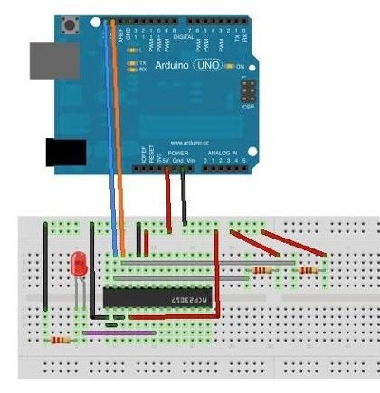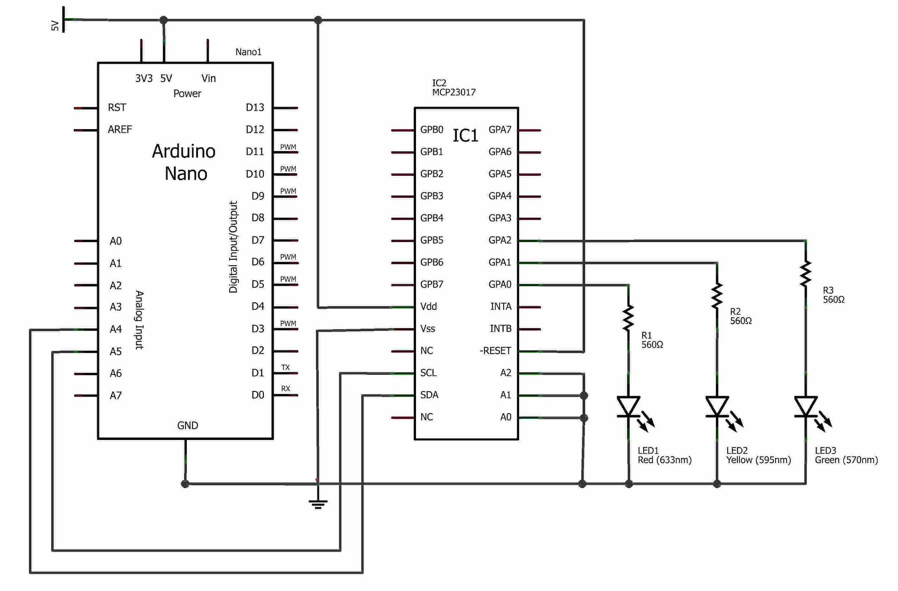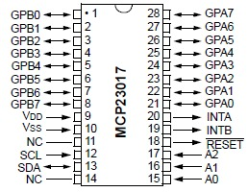

### Wiring

**To wire your MCP23017 Expander to your Arduino, connect the following pins:**

* **Pin 15 (A0) –> Arduino Ground**
* **Pin 16 (A1) –> Arduino Ground**
* **Pin 17 (A2) –> Arduino Ground**
* **Pin 18 (Reset) –> Arduino +5V**
* **Pin 19 (Int B) –> N/C**
* **Pin 20 (Int A) –> N/C**
* **Pin 21 – 28 –> Led Pin(+) via 470ohm Resistor**
* **Pin 1 – 8 –> N/C**
* **Pin 9 (Vdd) –> Arduino +5V**
* **Pin 10 (Vss) –> Arduino Ground**
* **Pin 11 –> N/C**
* **Pin 12 (Scl) –> Arduino Pin A5**
* **Pin 13 (Sda) –> Arduino Pin A4**
* **Pin 14 –> N/C**

**Don’t forget to wire all the Ground Pins of each Led to the Arduino Ground.**

### Recommended Software

* **none**

### Instructions and Code

**#include <Wire.h>**

**const** byte mcp_address**=**0x20; *// I2C Address of MCP23017 Chip*

**const** byte GPIOA**=**0x12; *// Register Address of Port A*

*//const byte GPIOB=0x13; // Register Address of Port B*

**const** byte sequence[8] **=** {0b00000001, 0b00000011, 0b00000111, 0b00001111, 0b00011111, 0b00111111, 0b01111111, 0b11111111};

*//The setup function is called once at startup of the sketch*

**void** **setup**()

{

Wire.begin();

Wire.beginTransmission(mcp_address);

Wire.write((byte)0x00);

Wire.write((byte)0x00); *// set all of bank A to outputs*

Wire.write((byte)0x00); *// set all of bank B to outputs*

Wire.endTransmission();

}

**void** **loop**()

{

**int** pos **=** 0;

**for** (pos**=**0; pos **<** 8; pos**++**)

{

Wire.beginTransmission(mcp_address);

Wire.write(GPIOA);

Wire.write((byte)sequence[pos]); *// value to send - all HIGH*

Wire.endTransmission();

delay(1000);

}

}